|  |
| --- |
| **MGMT** |

1 Configuration 2

1.1 TeamViewer 2

1.2 Background 2

1.3 Startscreen 3

# Configuration

## TeamViewer

Install the latest TeamViewer host version.

You can find the installer at the jdn-file01.

\\jdn-file01\Software$\Software - Windows Official\Teamviewer\

After the installation modify the name and folder at the TeamViewer Corporate computers & Contacts.

Name: “Ship name – MGMT01”

Example: “La Boudeuse – MGMT01”

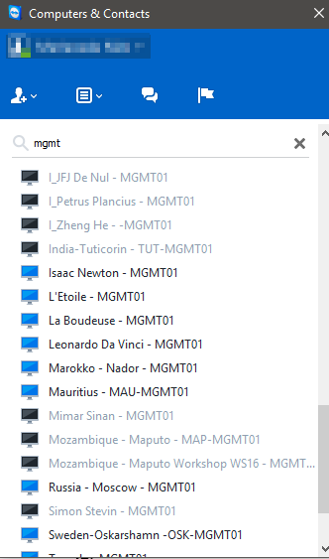

## Background

Change the backgroundcolor.

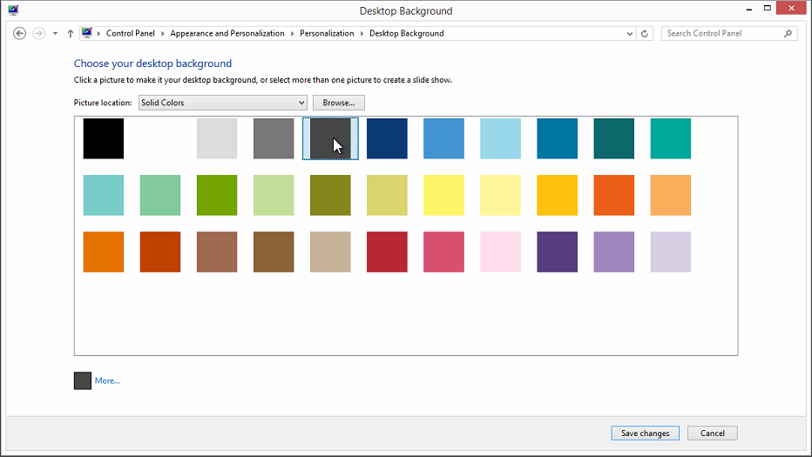

## Startscreen

Cleanup the startscreen.

